Question: 1 What is our independent variable? What is our dependent variable?

Answer1:

Independent variable: In this case our independent variable is colour of ink in which word is written.

Dependent variable: In this case our dependent variable it is the time to name the colour of the ink.

Question 2:What is an appropriate set of hypotheses for this task? What kind of statistical test do you expect to perform? Justify your choices.

Answer2:

For this particular task. We have identified the following hypotheses.

Null hypotheses: Null hypotheses are the case which suggest that there is no significant change in the population parameters before and after applying the treatment, in our particular case null hypothesis would be when population parameter from both the sample are similar

H0 : µc=µi

µc is the mean for congruent population.

µi is the mean for incongruent population.

Alternative hypotheses: Alternative hypotheses states that there is significant difference between the population parameters of 2 samples. In this case mean for incongruent sample population should be greater than the mean for congruent population mean.

HA: µi > µc (one tailed) (As per stroop analysis, Time taken to correctly identify the incongruent word is greater than congruent words ).

In would like to go for the actual test stroop test. That says time to recognize the incongruent words are greater than the congruent words. So i would like to prove that alternative hypothesis(incongruent words take more time to get recognized) stands true and not by chance.

Statistical Test:

We have the following choice for statistical test:

1.Z- test

2. T- test.

We are provided with 2 dependent sample dataset, one for congruent words and other for incongruent words and both samples are 24 in number.

Since 1 of the pre-requisite for Z- test is the population parameter , which we are not provide with and Z –test works well for the dataset size greater than 30.

In our project we are not provided with the population parameters (We have two different samples for congruent word and incongruent words) and sample dataset size is 24 which is less than 30 , The choice of paired T- statistic test become obvious.

Question 3 :Report some descriptive statistics regarding this dataset. Include at least one measure of central tendency and at least one measure of variability.

Answer 3:

Since we have two dependent data set ( the number of sample size , same participants controls the individual difference) our descriptive statistics are based on the difference between two sample dataset.

For Central tendency:

Mean is 7.964792

For Measure of variability

Standard deviation: 4.86482691

Question 4:. Provide one or two visualizations that show the distribution of the sample data. Write one or two sentences noting what you observe about the plot or plots.

Histogram for the Congruent:

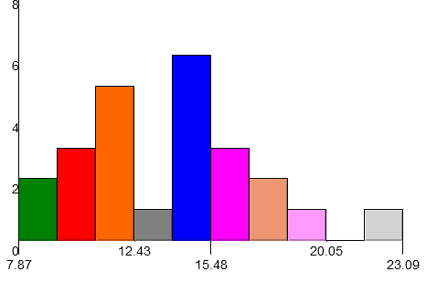

This data distribution seems to be normally distributed with maximum of frequencies lying around 15.48.

Histogram for Incongruent sample:

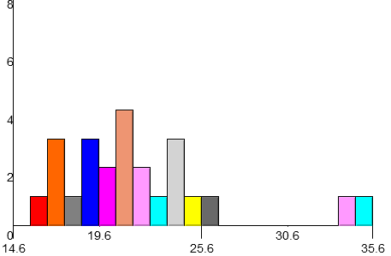

If we look closely then we can easily figure out that the maximum distribution lying in the middle around 22 and at both tail we have relatively lesser frequency. Hence this histogram is also normally distribution.

Question 5: Now, perform the statistical test and report your results. What is your confidence level and your critical statistic value? Do you reject the null hypothesis or fail to reject it? Come to a conclusion in terms of the experiment task. Did the results match up with your expectations?

Answer5:

Result:

Computation table:

|  |  |
| --- | --- |
| Confidence Level | 95% |
| Alpha level | 0.05 |
| Average of difference | 7.964791667 |
| Standard Error | 0.993028635 |
| T critical | 1.714 |
| T statistics | 8.020706944 |
| Reject or Accept Null Hypothesis | Reject Null hypothesis |
| Confidence interval | X - tcritical*SEM,X + critical*SEM |
| t critical of 95% of CI | 2.069 |
| Confidence interval(lower bound) | 5.910215421 |
| Confidence interval(upper bound) | 10.01936791 |

T critical value for α=0.05 is 1.714 for the one tailed alternative hypotheses. If we get T-Statistics (from t-test) greater than T critical value , then we can say that the different between the means of two sample is significant and not by chance. Since the probability that t-statistics lying after t-critical value on the distribution is very less (or less than 5%)

If we see the values of the parameter shared in the table above , we can easily figure out that

Tstatistics: 8.020706944

Tcritical: 1.714

α=0.05

p<0.05 or 5%

TStatistics is way far greater than the Tcritical value and the probability of lying t-statistic is after t-critical value on the distribution is less than 5%. Which enable us to conclude that our alternative hypotheses (mean time to recognize the incongruent word is greater than the congruent word) is significant and not by chance.

Results are matching with my expectation. Since my expectation was that incongruent sample would take longer time than the congruent sample data.

Question 6: Optional: What do you think is responsible for the effects observed? Can you think of an alternative or similar task that would result in a similar effect? Some research about the problem will be helpful for thinking about these two questions!

Answer:

I think, whenever we see a word we prefer to read the word rather than seeing the examine the colour.

Alternative or similar effect task would be correctly recognizing a word irrespective of different colour. Like green is written in red colour and we have to say green.

Or similar task would be to have mapping like associating

Orange to banana

Banana to grape

Grape to Apple.

So whenever we encounter an orange we have to say it banana, whenever we encounter a banana we have to say grape. Whenever we encounter a grape we have to say apple.